Name _____________________________________________________________________________
-an word family
Directions: Choose a can. Color it appropriately. Write the word for the picture that is on the can. All words will end with -an.

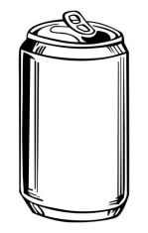
- __________________________ 4. ___________________________

- ___________________________ 5. ___________________________

- ___________________________ 6. ___________________________

Choose 1 –an word and write a sentence.
__________________________________________________________________________________
__________________________________________________________________________________

